Multimodal Threat Intelligence Platform Architecture

1. System Engineering Blueprint
A modern threat architecture cannot rely solely on computer vision or perimeter logs. It requires a unified pipeline from physical sensors up to agentic reasoning engines:
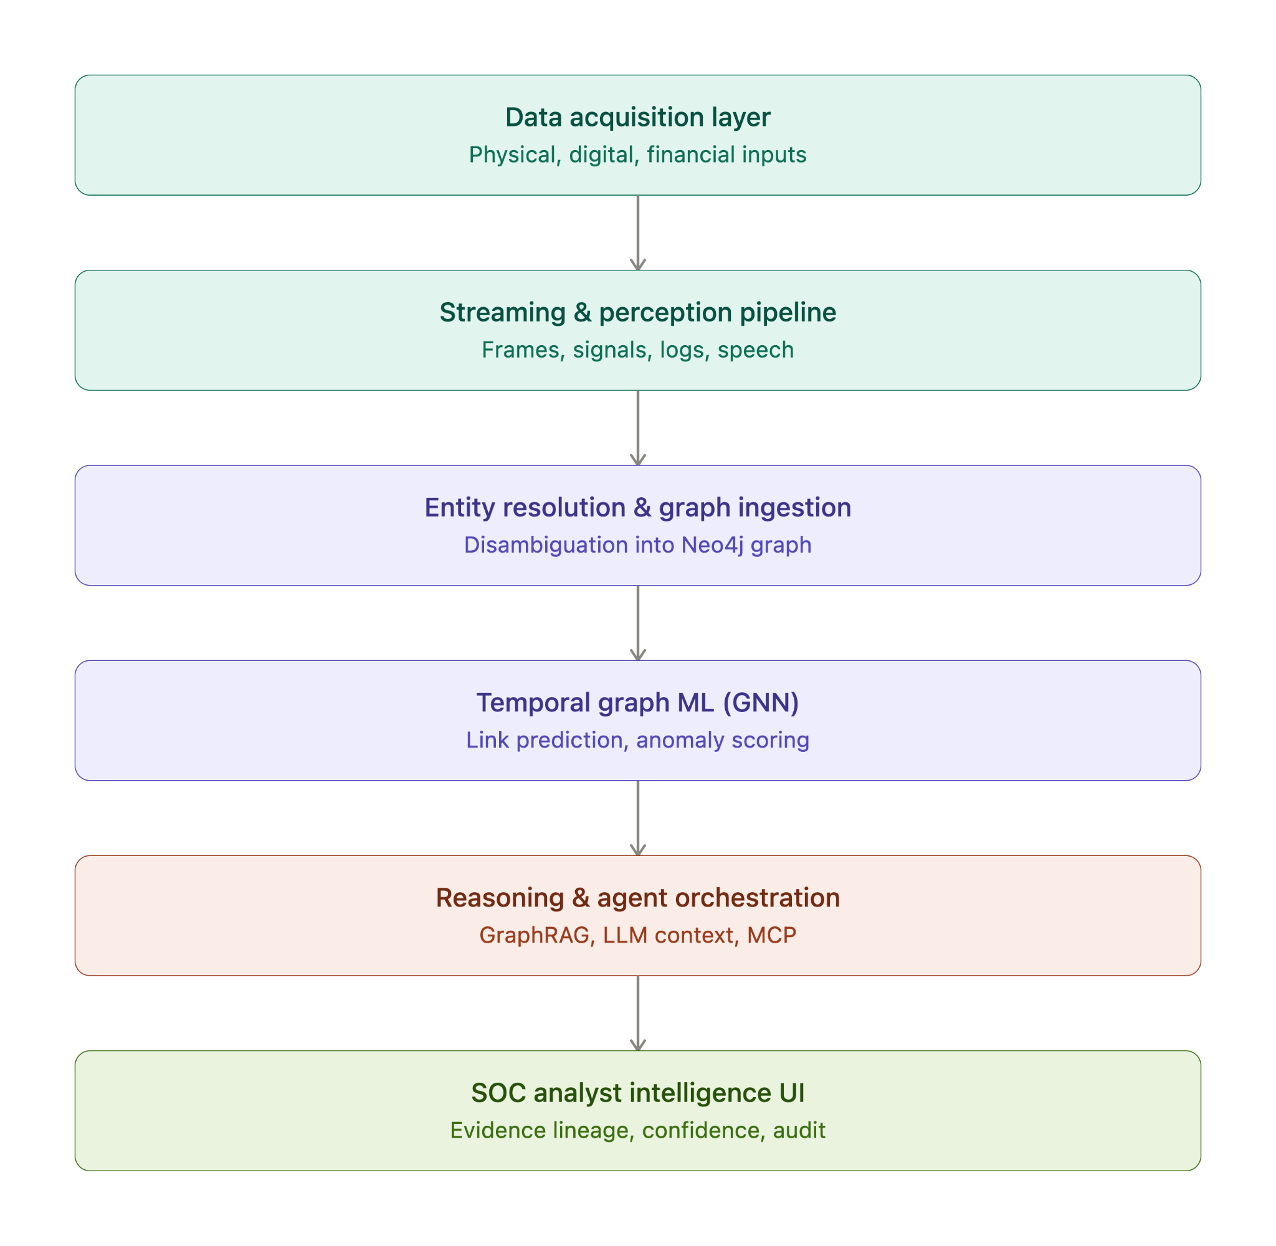

2. 12-Layer Functional Specification for Terrorist Actor Identification & Entity Linkage

Layer 1: Visible Computer Vision (Reconnaissance & Physical Linkage)

Sensor & Extraction: Bounding box detection, human pose tracking, vehicle tracking, and trajectory mapping via YOLO and ByteTrack/BoT-SORT.

Actor Identification: Identifies specific operatives engaged in pre-operational surveillance, unauthorized perimeter probing around critical infrastructure, or weapon handling.

Linkage Mechanism: Resolves physical movements into persistent TrackID nodes, binding physical individuals to specific vehicles (license plates) and observed tactical gear.

Layer 2: Identity & Biometric Verification (Watchlist Disambiguation)

Sensor & Extraction: High-dimensional facial vector embeddings generated via RetinaFace and ArcFace.

Actor Identification: Direct matching against sanctioned terror watchlists, biometric border-control databases, and Interpol red notices under variable lighting or partial concealment (hats, masks).

Linkage Mechanism: Binds an unconfirmed physical track (Track_892) to a real-world sovereign identity or alias (Person_Entity_X), merging previously separated aliases across disparate incident reports.

Layer 3: Thermal Radiometric Sensing (Concealed Operations & Night Logistics)

Sensor & Extraction: Long-wave infrared (LWIR) radiometric thermal sensors extracting differential heat signatures.

Actor Identification: Uncovers operatives operating under blackout conditions, concealed staging camps, safehouses with abnormal cooling/power signatures, or perimeter breeches through tree lines.

Linkage Mechanism: Tags vehicles based on engine-block thermal signatures (determining recent vehicle operation times) and maps human heat trails to hidden underground or disguised structures.

Layer 4: RF & Wi-Fi CSI Sensing (Non-Line-of-Sight Presence Detection)

Sensor & Extraction: IEEE 802.11bf Channel State Information (CSI) subcarrier perturbation analysis.

Actor Identification: Identifies human presence, respiration, and movement within reinforced safehouses or closed rooms without requiring line-of-sight cameras.

Linkage Mechanism: Flags "dark safehouses" where no registered occupants reside, counting hidden occupants and associating their presence with simultaneous wireless beacon transmissions.

Layer 5: Micro-Doppler Radar (Gait Analysis & Covert Transport)

Sensor & Extraction: FMCW millimeter-wave (mmWave) radar measuring frequency shifts, range, and velocity.

Actor Identification: Extracts unique biological gait profiles to track suspected operatives even if faces are completely obscured, and distinguishes concealed military-grade payloads within standard vehicular compartments.

Linkage Mechanism: Connects tactical movements across adverse weather conditions (fog, dust storms) to specific physical transit corridors.

Layer 6: Audio & Speech Forensics (Voiceprint & Operational Signals)

Sensor & Extraction: Speaker diarization, acoustic vector embeddings (wav2vec 2.0/Whisper), and transcription.

Actor Identification: Matches intercepted voice communications against known terrorist leadership audio archives to confirm high-value targets (HVTs) using shared or unverified satellite/cellular connections.

Linkage Mechanism: Maps explicit operational jargon, code phrases, and commands to caller-receiver communication edges (Person_A -[:COMMUNICATED_WITH]-> Person_B).

Layer 7: Behavioral Sequence Analysis (Anomalous OPSEC Deviations)

Sensor & Extraction: Sequential deviation modeling against baseline normative patterns.

Actor Identification: Detects deliberate operational security (OPSEC) tradecraft—such as abrupt "go-dark" behavior, sequential SIM-swapping, erratic counter-surveillance driving paths, or off-hour physical visits to secondary locations.

Linkage Mechanism: Binds sudden deviations across physical activity directly to planned activation schedules or cyber attack windows.

Layer 8: Dynamic Social & Network Graphs (Cell Structure & Cell Isolation)

Sensor & Extraction: Graph topological clustering, Louvain/Leiden community detection, and centrality metrics.

Actor Identification: Isolates the operational coordinator, courier, or logistical facilitator who acts as a high-betweenness bridge between compartmentalized sub-cells.

Linkage Mechanism: Traces indirect trust networks (e.g., Person A never calls Person B directly, but both interface with Mule C), resolving the entire cell boundary rather than a single lone actor.

Layer 9: Transactional & Asset Graphs (Terrorist Logistics & Financing / CTF)

Sensor & Extraction: Graph-based anti-money laundering (AML) and counter-terrorist financing (CTF) modeling across fiat structuring, micro-transfers, and crypto mixer peel-chains.

Actor Identification: Flags the operational financier or procurement officer purchasing dual-use precursors, satellite internet access, domain names, or tactical gear.

Linkage Mechanism: Merges anonymous transaction IDs (TX_104) and destination crypto wallets into the specific operational actor node that deployed the corresponding network infrastructure.

Layer 10: Cyber Telemetry & CTI Attribution (Technical TTP Footprint)

Sensor & Extraction: Ingestion of NetFlow, SIEM alerts, EDR process executions, and MITRE ATT&CK TTP mapping.

Actor Identification: Correlates offensive network scanning, living-off-the-land malware binaries, and command-and-control (C2) beaconing to known Advanced Persistent Threat (APT) groups or hostile cyber warfare units.

Linkage Mechanism: Connects outbound external reconnaissance scans from target infrastructure back to internal digital endpoints and staging servers.

Layer 11: OSINT & Surface Web Intelligence (Recruitment & Ideological Footprint)

Sensor & Extraction: Natural language entity extraction (NER) over dark web forums, extremist channels, public registries, and paste sites.

Actor Identification: Surfaces claims of responsibility, recruitment outreach, digital propaganda dissemination, and public-facing operational manifestos tied to specific handles or phone numbers.

Linkage Mechanism: Resolves disparate online pseudonyms, forum IDs, and PGP key fingerprints to the same physical actor cluster via text embedding similarity.

Layer 12: Logistics, Physical Infrastructure & C2 (Staging & Interdiction Planning)

Sensor & Extraction: Geospatial movement records, GPS telemetry, real-estate lease tracking, and supply chain manifests.

Actor Identification: Identifies weapon caches, staging warehouses, vehicle rental clusters, and critical infrastructure target locations.

Linkage Mechanism: Provides the spatial-temporal anchor linking the cyber probe (Layer 10), financial purchase (Layer 9), and physical presence (Layer 1/2), establishing the evidentiary convergence required for lawful interdiction.

3. Technology Stack & Protocol Orchestration
Infrastructure Tier | Recommended Production Tooling | Operational Role
Edge Vision & RF | Ultralytics YOLO, PyTorch, Linux Wi-Fi CSI Drivers | Real-time object tracking, pose estimation, and RF disturbance ingestion.
Streaming Pipeline | Apache Kafka, Vector / Fluentbit | Low-latency stream ingestion of high-volume telemetry and physical sensor events.
Graph Database | Neo4j Enterprise (Graph Data Science Library) | Multilayer entity storage, temporal relationship indexing, and Cypher queries.
Graph ML Engine | PyTorch Geometric (PyG), DGL | Dynamic Temporal GNNs for link prediction, anomaly flagging, and cell detection.
Agent Interface | Model Context Protocol (MCP) Servers | Secure protocol bridges connecting reasoning models directly to Cypher and SQL.
Reasoning Engine | GraphRAG + Fine-tuned LLM Orchestration | Synthesizing graph subgraphs into contextual analyst intelligence briefings.

4. Operational Risk, Ethics, and Governance Standard
To adhere to the NIST Artificial Intelligence Risk Management Framework (AI RMF 1.0) and prevent high-consequence system failures:
- Elimination of Pseudoscience Predictors: The platform must not predict threat levels based on facial micro-expressions, speech sentiment, emotional state, or socio-cultural categorizations.
- Auditable Evidence Provenance: Threat scores cannot exist as opaque numbers. Every alert must display an explicit chain of evidence linking raw sensor events, specific database IDs, and timestamps.
- Dual-Key Human Authorization: Automated pipelines identify correlation anomalies; human intelligence analysts retain sole authority over operational escalation and real-world interventions.

